Program-01
Develop a program to illustrate the working of LED with push button
#define buttonPin 4 // the number of the pushbutton pin
#define ledPin 13 // the number of the LED pin
int buttonState = 0; // variable for reading the pushbutton
void setup() {
// initialize the LED pin as an output:
pinMode(ledPin,OUTPUT);
// initialize the pushbutton pin as an input:
pinMode(buttonPin, INPUT);
}
void loop() {
buttonState = digitalRead(buttonPin);
// check if the pushbutton is pressed. If it is, the buttonState is HIGH:
if (buttonState == HIGH) {
// turn LED on:
digitalWrite(ledPin, LOW);
}
else {
// turn LED off:
digitalWrite(ledPin,HIGH);
}
}
OUTPUT

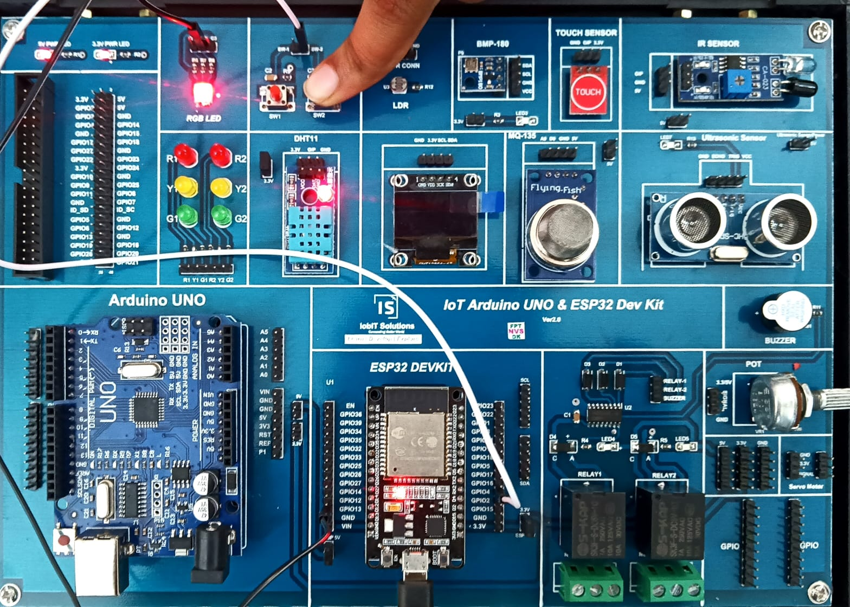

Program –02
Develop a program to illustrate the working of traffic lights for pedstrians.
// Pin definitions
const int carRed = 25;
const int carYellow = 26;
const int carGreen = 27;
const int pedRed = 14;
const int pedGreen = 12;

void setup() {
// Set LED pins as output
pinMode(carRed, OUTPUT);
pinMode(carYellow, OUTPUT);
pinMode(carGreen, OUTPUT);
pinMode(pedRed, OUTPUT);
pinMode(pedGreen, OUTPUT);
// Initialize traffic light (green for cars, red for pedestrians)
digitalWrite(carGreen, HIGH);
digitalWrite(pedRed, HIGH);
}

void loop() {
// Step 1: Green light for cars, red for pedestrians
digitalWrite(carGreen, HIGH);
digitalWrite(carYellow, LOW);
digitalWrite(carRed, LOW);
digitalWrite(pedGreen, LOW);
digitalWrite(pedRed, HIGH);
delay(5000); // Cars move for 5 seconds
// Step 2: Yellow light for cars, red for pedestrians
digitalWrite(carGreen, LOW);
digitalWrite(carYellow, HIGH);
delay(2000); // Yellow light for 2 seconds
// Step 3: Red light for cars, green for pedestrians
digitalWrite(carYellow, LOW);
digitalWrite(carRed, HIGH);
digitalWrite(pedRed, LOW);
digitalWrite(pedGreen, HIGH);
delay(5000); // Pedestrians cross for 5 seconds
// Step 4: Flash yellow light for cars before green light
digitalWrite(pedGreen, LOW);
digitalWrite(pedRed, HIGH);
for (int i = 0; i < 3; i++) {
digitalWrite(carYellow, HIGH);
delay(500);
digitalWrite(carYellow, LOW);
delay(500);
}
}

OUTPUT
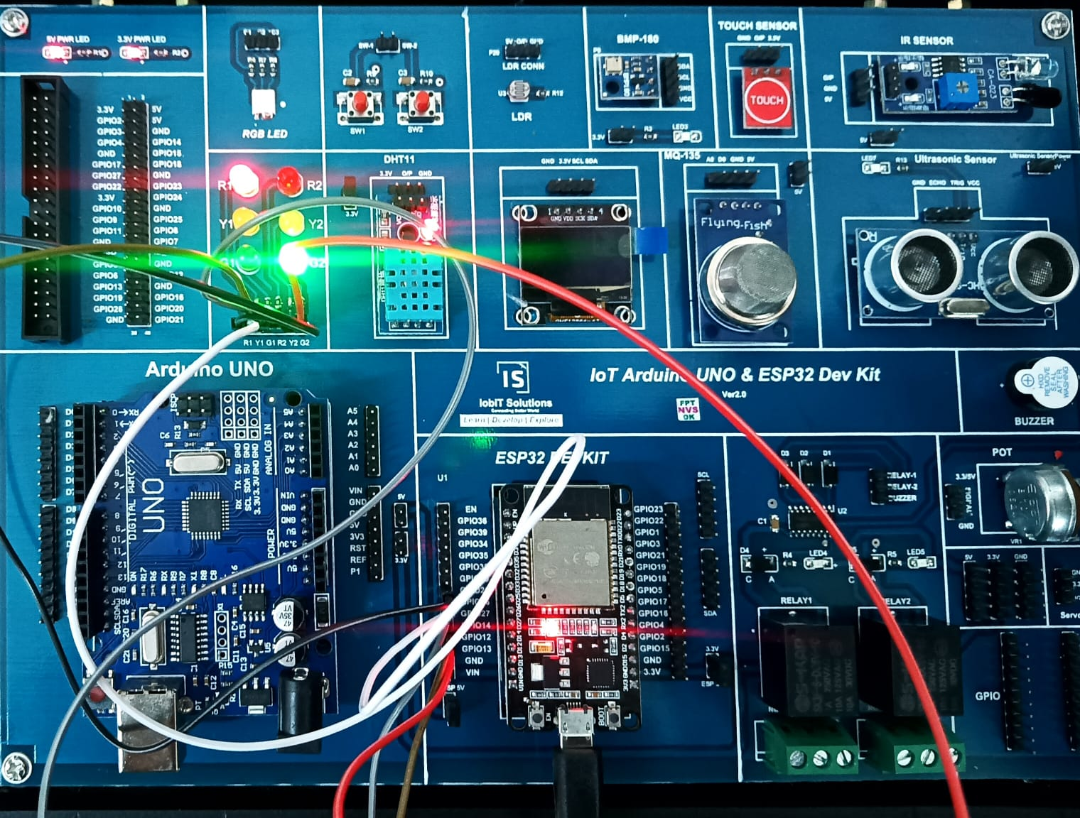

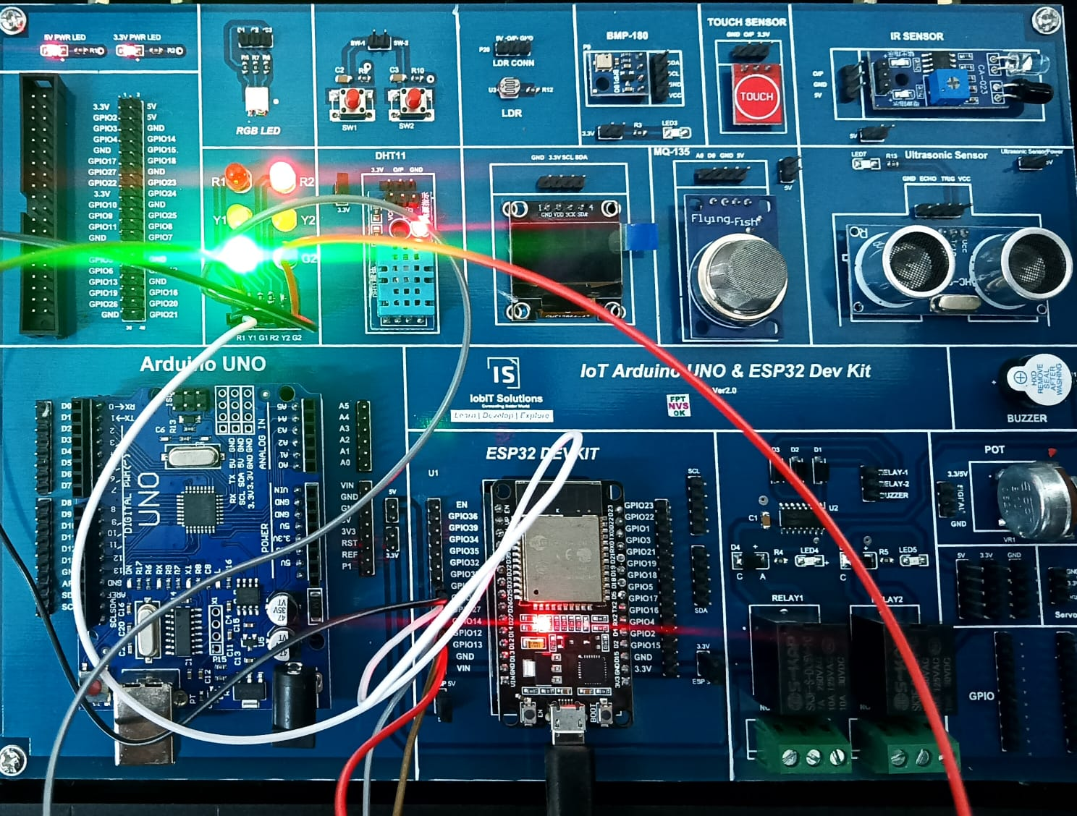

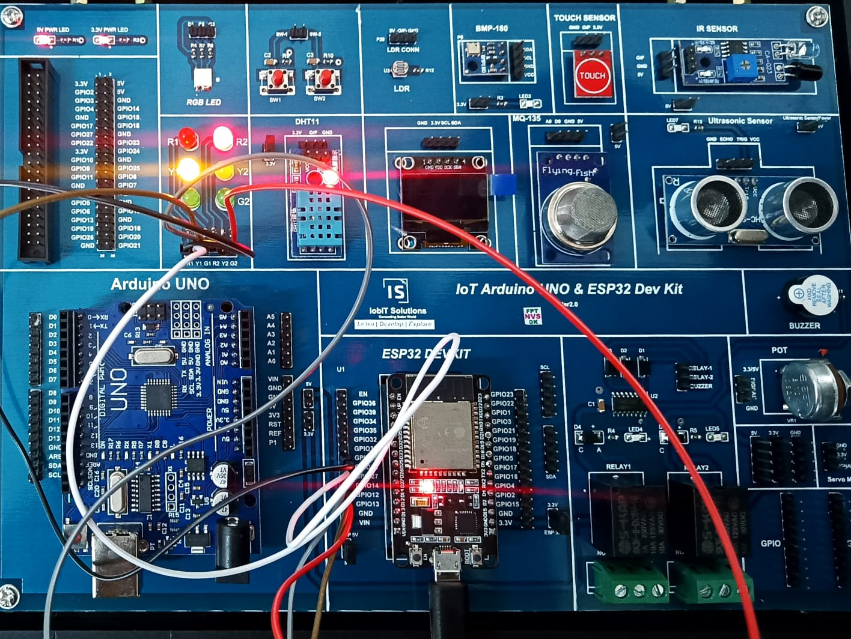

PROGRAM—03
Develop a program for fading the LED
#define ledPin 5 // Pin for the LED (can be changed based on yourboard)
int brightness = 0; // Initial brightness level
int fadeAmount = 5; // Amount by which the brightness will increase/decrease
void setup() {
// Set the LED pin as an output
pinMode(ledPin, OUTPUT);
}
void loop() {
// Set the brightness of the LED using PWM
analogWrite(ledPin, brightness);
// Change the brightness for the next loop
brightness = brightness + fadeAmount;
// Reverse the direction of the fading if brightness reaches max or min
if (brightness <= 0 || brightness >= 255) {
fadeAmount = -fadeAmount;
}
// Delay for a smoother fading effect
delay(30); // Adjust this for faster/slower fading
}
OUTPUT:

Program 4.
Program to blink 6 LEDs in ODD and Even Fashion.
// Pin definitions for the odd and even LEDs
#define led1 12 // Odd
#define led3 13 // Odd
#define led5 14 // Odd
#define led2 25 // Even
#define led4 26 // Even
#define led6 27 // Even

void setup() {
// Set all the LED pins as outputs
pinMode(led1, OUTPUT);
pinMode(led2, OUTPUT);
pinMode(led3, OUTPUT);
pinMode(led4, OUTPUT);
pinMode(led5, OUTPUT);
pinMode(led6, OUTPUT);
}
void loop() {
// Turn on all odd-numbered LEDs (1, 3, 5)
digitalWrite(led1, HIGH);
digitalWrite(led3, HIGH);
digitalWrite(led5, HIGH);
// Turn off all even-numbered LEDs (2, 4, 6)
digitalWrite(led2, LOW);
digitalWrite(led4, LOW);
digitalWrite(led6, LOW);
delay(1000); // Wait for 1 second
// Turn off all odd-numbered LEDs (1, 3, 5)
digitalWrite(led1, LOW);
digitalWrite(led3, LOW);
digitalWrite(led5, LOW);
// Turn on all even-numbered LEDs (2, 4, 6)
digitalWrite(led2, HIGH);
digitalWrite(led4, HIGH);
digitalWrite(led6, HIGH);
delay(1000); // Wait for 1 second
}

OUTPUT:
EVEN FASHION

ODD FASHION
5. Program to rotate servo motor both in clockwise and
anticlockwise direction.
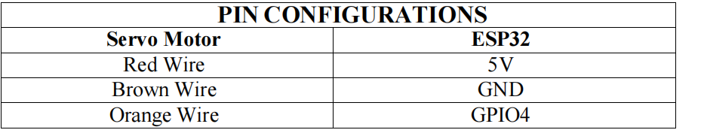
#include <ESP32Servo.h> // Include the ESP32 Servo library
Servo myServo; // Create a Servo object
int pos = 0; / / Variable to store the servo position

void setup() {
myServo.attach(4); // Attach the servo to pin 4
}

void loop() {
// Rotate the servo clockwise (from 0 to 180 degrees)
for (pos = 0; pos <= 180; pos += 1) {
myServo.write(pos); // Set the servo to the current position
delay(15); // Wait for 15ms for the servo to reach the position
}
// Rotate the servo anticlockwise (from 180 back to 0 degrees)
for (pos = 180; pos >= 0; pos -= 1) {
myServo.write(pos); // Set the servo to the current position
delay(15); // Wait for 15ms for the servo to reach the position
}
}

OUTPUT:

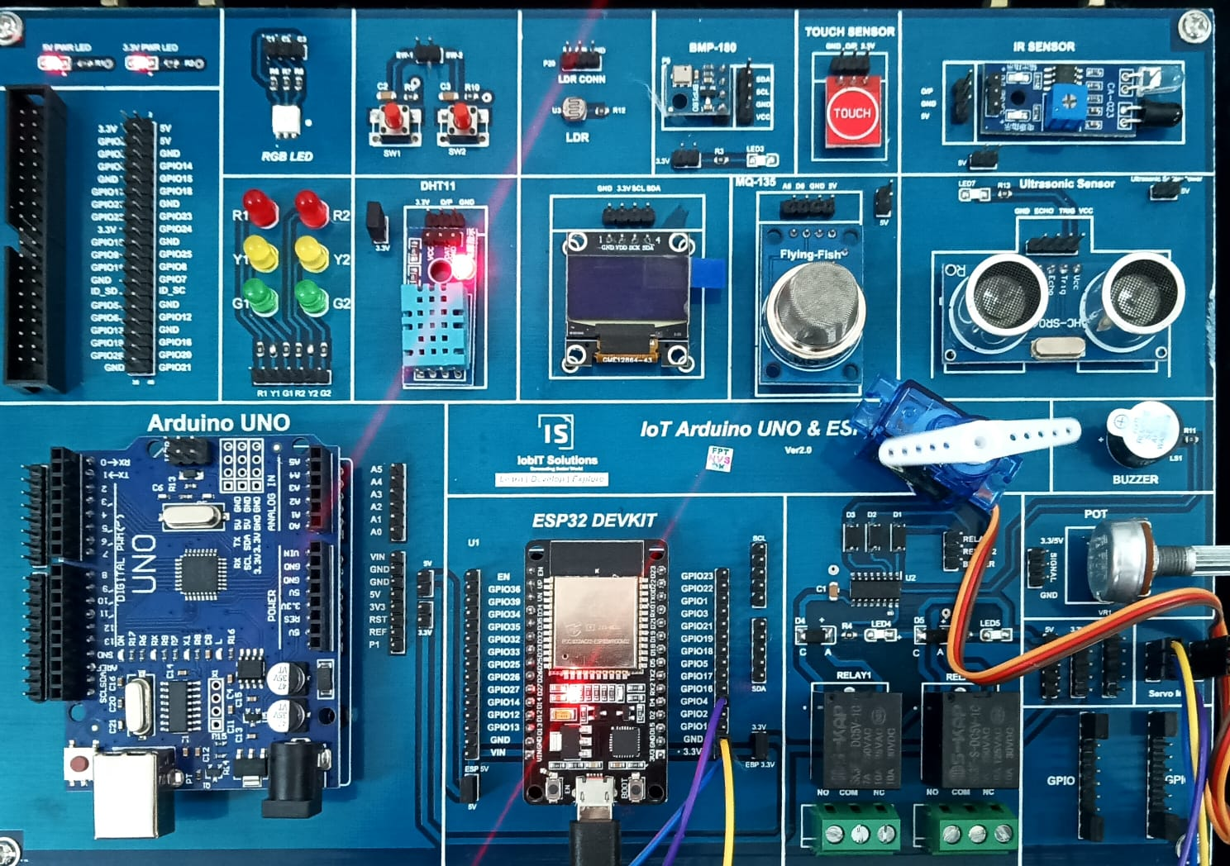

PROGRAM-06
Develop a program to simulate the interfacing of LDR with Arduino and control the intensity of LED using LDR
#define ldrPin 15 // Pin connected to the LDR
#define ledPin 4 // Pin connected to the LED
int ldrValue = 0; // Variable to store LDR reading
int ledBrightness = 0; // Variable to store LED brightness

void setup() {
pinMode(ledPin, OUTPUT); // Set the LED pin as output
Serial.begin(9600); // Start serial communication for debugging
}

void loop() {
// Read the value from the LDR (0 to 1023)
ldrValue = analogRead(ldrPin);
// Map the LDR value to a range of 0 to 255 for PWM (LED brightness)
ledBrightness = map(ldrValue, 0, 1023, 0, 255);
// Set the brightness of the LED using PWM
analogWrite(ledPin, ledBrightness);
// Debugging information
Serial.print("LDR Value: ");
Serial.print(ldrValue);
Serial.print(" LED Brightness: ");
Serial.println(ledBrightness);
delay(100); // Short delay for stability
}

OUTPUT:

PROGRAM-07
Develop program to simulate the working of potentiometer and LED by varying the intensity of LED using potentiometer.
#define potPin 15 // Pin connected to the PoT
#define ledPin 4 // Pin connected to the LED
int potValue = 0; // Variable to store PoT reading
int ledBrightness = 0; // Variable to store LED brightness

void setup() {
pinMode(ledPin, OUTPUT); // Set the LED pin as output
Serial.begin(9600); // Start serial communication for debugging
}

void loop() {
// Read the value from the PoT (0 to 1023)
potValue = analogRead(potPin);
// Map the PoT value to a range of 0 to 255 for PWM (LED brightness)
ledBrightness = map(potValue, 0, 1023, 0, 255);
// Set the brightness of the LED using PWM
analogWrite(ledPin, ledBrightness);
// Debugging information
Serial.print("Pot Value: ");
Serial.print(potValue);
Serial.print(" LED Brightness: ");
Serial.println(ledBrightness);
delay(100); // Short delay for stability
}

8. Program to simulate the working of OLED and print the room
temperature value on OLED.
#include <Wire.h>//
#include <Adafruit_GFX.h>
#include <Adafruit_SSD1306.h>
#include "DHT.h"
#define DHTPIN 4 // Pin connected to the DHT11 sensor
#define DHTTYPE DHT11 // Type of DHT sensor
#define SCREEN_WIDTH 128 // OLED display width, in pixels
#define SCREEN_HEIGHT 64 // OLED display height, in pixels
// Declaration for an SSD1306 display connected to I2C (SDA, SCL pins)
Adafruit_SSD1306 display(SCREEN_WIDTH, SCREEN_HEIGHT, &Wire,
-1);
DHT dht(DHTPIN, DHTTYPE);
float t = 0,h = 0;

void setup() {
Serial.begin(9600);
// Initialize the OLED display
if(!display.begin(SSD1306_SWITCHCAPVCC, 0x3C)) {
Serial.println(F("SSD1306 allocation failed"));
}
dht.begin();
}
void loop() {
t = dht.readTemperature();
h = dht.readHumidity();
display.clearDisplay();
display.setTextSize(1);
display.setTextColor(SSD1306_WHITE);
display.setCursor(0,0);
display.print("Temperature = ");
display.println(t);
display.print("Humidity = ");
display.println(h);
display.display();
delay(3000);
}

9. Program for scrolling 5 LEDs back and forth.
// Pin definitions for the 5 LEDs
const int ledPins[] = {12, 13, 14, 25, 26, 27}; // Define LED pins
const int numLeds = 6; // Total number of LEDs

void setup() {
// Set all the LED pins as outputs
for (int i = 0; i < numLeds; i++) {
pinMode(ledPins[i], OUTPUT);
}
}

void loop() {
// Scroll LEDs from left to right (forward)
for (int i = 0; i < numLeds; i++) {
digitalWrite(ledPins[i], HIGH); // Turn on the current LED
delay(200); // Wait for 200ms
digitalWrite(ledPins[i], LOW); // Turn off the current LED
}
// Scroll LEDs from right to left (backward)
for (int i = numLeds - 1; i >= 0; i--) {
digitalWrite(ledPins[i], HIGH); // Turn on the current LED
delay(200); // Wait for 200ms
digitalWrite(ledPins[i], LOW); // Turn off the current LED
}
}
OUTPUT:

10. Program to calculate the distance of an object using ultrasonic sensor.
#include <Ultrasonic.h>
#define TRIG 5
#define ECHO 4
Ultrasonic US(TRIG, ECHO);

int distance ;
void setup() {
Serial.begin(9600);
}

void loop() {
// Pass INC as a parameter to get the distance in inches
distance = US.read();
Serial.print("Distance in CM: ");
Serial.println(distance);
delay(1000);
}

OUTPUT:

11. Program to detect the collision using infrared sensor.
#define IR 15
void setup() {
// put your setup code here, to run once:
pinMode(IR,INPUT);
Serial.begin(9600);
}

void loop() {
// put your main code here, to run repeatedly:
int ir = digitalRead(IR);
// Serial.print(ir);
// delay(500);
if(ir == 1)
Serial.println("Object Not Detected");
else
Serial.println("Object Detected");
delay(1000);
}

12. Program to interface temperature sensor to read the room temperature, humidity and heat index and print the readings on the serial monitor.
#include "DHT.h"
#define DHT11PIN 4
DHT dht(DHT11PIN, DHT11);

void setup() {
Serial.begin(9600); // Start the DHT11 Sensor
dht.begin();
}

void loop() {
float humi = dht.readHumidity();
float temp = dht.readTemperature();
// Using String() to concatenate
Serial.print("Temperature");
Serial.println(temp);
Serial.print("Humidity");
Serial.println(humi);
delay(1000); // 1-second delay between readings
}

OUTPUT:

